TAILWINDCSS TUTORIAL
- COLOR, SIZING AND BORDER
<div className="text-rose-300 bg-red-500">one</div>
<div className="text-slate-400 border-2 border-slate-600">two</div>
<div className="text-2xl bg-emerald-200 text-blue-600">three</div>

<div className="text-xl text-purple-500">
<div className="border-4 border-sky-500">four</div>
<div className="bg-violet-200 border-l-8 border-purple-800">five</div>

Result:
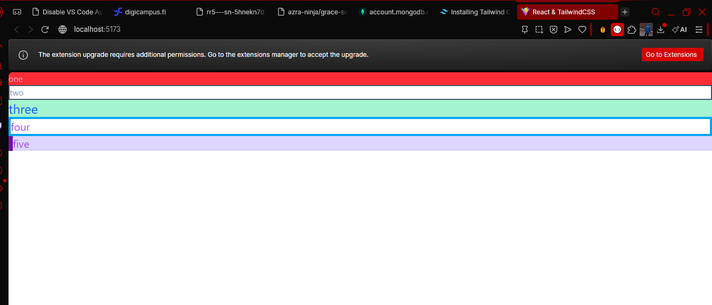

- PADDING & MARGIN
<button className="border-2 border-green-600 text-green-400 px-8 py-2 m-4 rounded-md">
first
</button>
<button className="rounded-lg bg-sky-400 text-white px-10 py-4 text-3xl m-4">
second
</button>
<button className="bg-violet-100 text-violet-600 px-8 py-2 rounded-full m-4">
third
</button>

<button className="m-4 bg-cyan-700 text-cyan-200 p-10 rounded-lg hover:bg-cyan-200 hover:text-cyan-700">
fourth
</button>

Result:
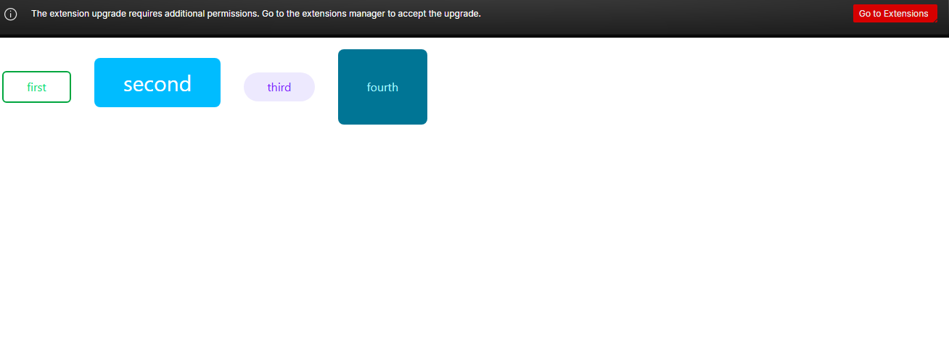
NOTE: Padding takes care of the inner element while margin takes care of the outer element
- TENARY OPERATORS USING TAILWIND
<div className={`${boolean ? "bg-orange-500" : "bg-purple-500"}`}>todo</div>
- CONDITIONAL STYLES AND CHILDREN PROPS ATTRIBUTE
App.jsx:
<div>
<FancyButton >click me</FancyButton>
<FancyButton large>my button</FancyButton>
</div>

FancyButton.jsx:
const FancyButton = ({ children, large }) => {
const largeStyle = large ? "text-3xl rounded-full" : "text-base rounded-md";
return (
<button
className={`bg-blue-200 border-2 border-blue-700 text-blue-700 px-10 py-2 m-4 ${largeStyle}`}
>
{children}
</button>
);
};

export default FancyButton;

Result:
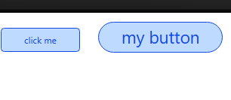
- FLEX, JUSTIFY, ALIGN ITEMS
App.jsx
<div>
<div className="flex justify-center h-64 p-4 m-4 border-2 border-blue-400">
<Cat />
<Cat />
<Cat />
</div>
<div className="flex justify-between h-64 p-4 m-4 border-2 border-red-400">
<Cat />
<Cat />
<Cat />
</div>
<div className="flex items-center justify-center h-64 p-4 m-4 border-2 border-green-400">
<Cat />
<Cat />
<Cat />
</div>
<div className="flex justify-around items-end h-64 p-4 m-4 border-2 border-purple-400">
<Cat />
<Cat />
<Cat />
</div>
<div className="flex justify-between items-center h-64 p-4 m-4 border-2 border-orange-400">
<Cat />
<Cat />
<Cat />
</div>
</div>

Cat.jsx
import { faCat } from "@fortawesome/free-solid-svg-icons/faCat";
import { FontAwesomeIcon } from "@fortawesome/react-fontawesome";

const Cat = () => {
return (
<div className="p-2 border-2 rounded-lg border-amber-600">
<FontAwesomeIcon icon={faCat} className="text-7xl text-amber-400" />
</div>
);
};

export default Cat;

Result:
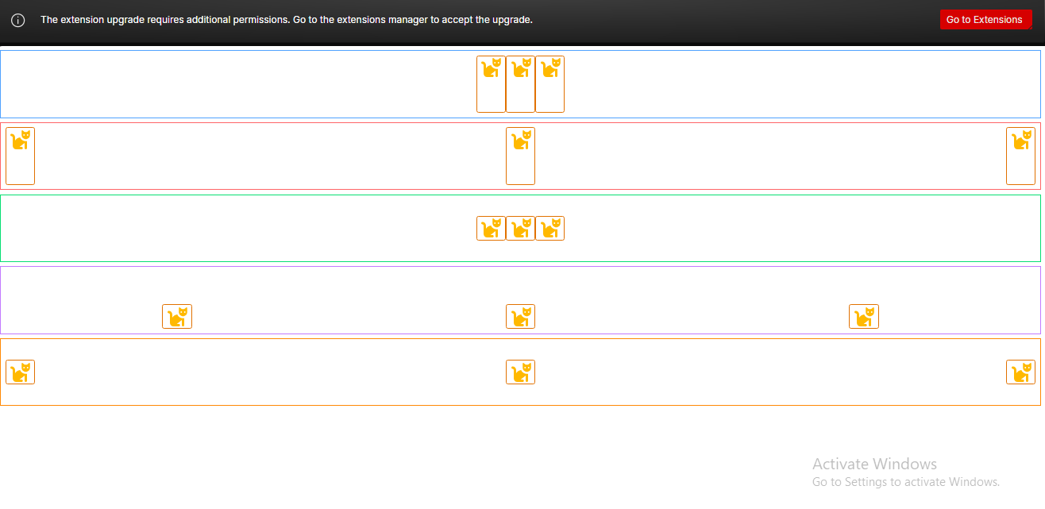
NOTE: Justify takes the x-axis(horizontally) while items takes the y-axis(vertically) positions. Lastly when a flex style is called the items are stacked in a horizontal way

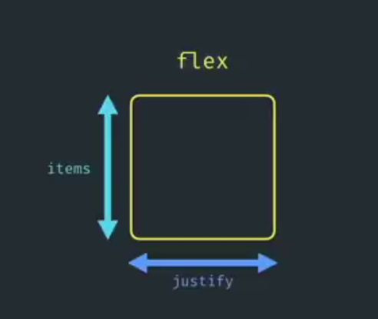
This is the flow of how flex works

- FLEX COLUMN
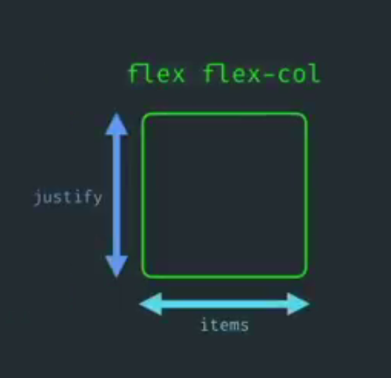
This is the flow for flex column

App.jsx:
import Box1 from "./Box1";
import Box2 from "./Box2";
import Box3 from "./Box3";
import Box4 from "./Box4";

function App() {
return (
<>
<Box1 />
<Box2 />
<Box3 />
<Box4 />
</>
);
}

export default App;

Box1.jsx:
import Dog from "./Dog";

const Box1 = () => {
return (
<div className="flex justify-center items-center h-64 p-4 m-4 border-2 border-blue-400">
<Dog />
<Dog />
<Dog />
</div>
);
};

export default Box1;

Box2.jsx:
import Dog from "./Dog";

const Box2 = () => {
return (
<div>
<div className="flex flex-col justify-between items-center h-64 p-4 m-4 border-2 border-gray-300">
<Dog />
<Dog />
<Dog />
</div>
</div>
);
};

export default Box2;

Box3.jsx:
import Dog from "./Dog";

const Box3 = () => {
return (
<div>
<div className="flex flex-col items-center justify-end h-64 p-4 m-4 border-2 border-cyan-400">
<Dog />
<Dog />
<Dog />
</div>
</div>
);
};

export default Box3;

Box4.jsx:
import Dog from "./Dog";

const Box4 = () => {
return (
<div>
<div className="flex flex-col justify-between items-end h-64 p-4 m-4 border-2 border-red-700">
<Dog />
<Dog />
<Dog />
</div>
</div>
);
};

export default Box4;

Dog.jsx:
import { faDog } from "@fortawesome/free-solid-svg-icons";
import { FontAwesomeIcon } from "@fortawesome/react-fontawesome";

const Dog = () => {
return (
<div>
<FontAwesomeIcon icon={faDog} className="text-5xl text-blue-600" />
</div>
);
};

export default Dog;

Result:
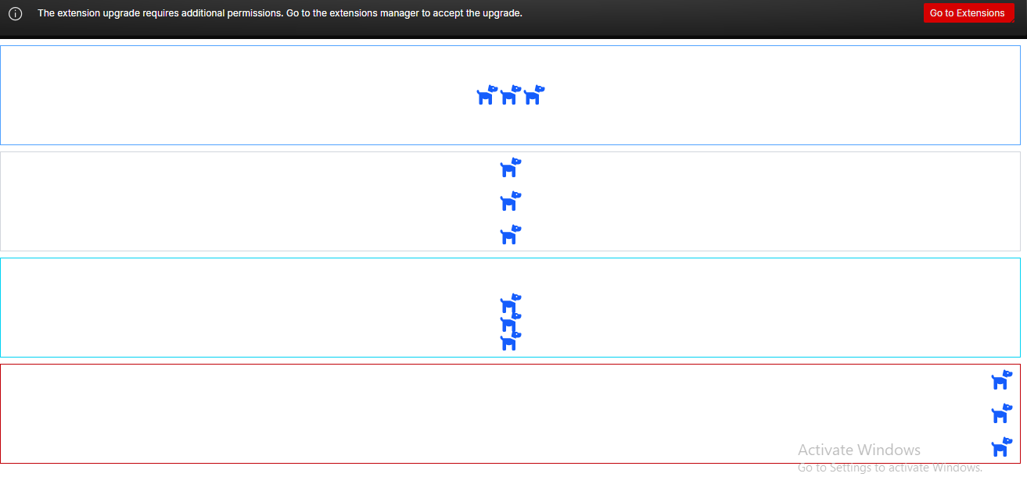
NOTE: Justify takes the y-axis(vertically) while items takes the x-axis(horizontally) positions. Lastly when a flex column style is called the items are stacked in a vertical way

Example:
App.jsx:
import QuoteBox1 from "./QuoteBox1";
import QuoteBox2 from "./QuoteBox2";
import QuoteBox3 from "./QuoteBox3";

const quote1 = {
text: "One of my most productive days was throwing away 1000 lines of code",
author: "Ken Thompson",
bio: "Designer of Unix Operating System"
};

const quote2 = {
text: "A ship in port is safe, but that's now what ships are built for",
author: "Admiral Grace Hopper",
bio: "Inventor of Programming Compilers"
};

const quote3 = {
text: "If you optimize everything, you will always be unhappy",
author: "Donald Knuth",
bio: "Pioneer of Algorithm Analysis"
};

function App() {
return (
<>
<div className="flex flex-col items-center">
<QuoteBox1 quote={quote1} />
<QuoteBox2 quote={quote2} />
<QuoteBox3 quote={quote3} />
</div>
</>
);
}

export default App;

QuoteBox1.jsx:
const QuoteBox1 = ({ quote }) => {
return (
<div className="flex flex-col m-4">
<div className="bg-cyan-500 py-8 px-6 w-[400px] text-cyan-200 rounded-t-lg ">
{quote.text}
</div>
<div className="bg-stone-100 p-4 flex flex-col items-center rounded-b-lg border border-stone-200">
<div className="text-cyan-700 text-2xl mb-2">{quote.author}</div>
<div className="text-stone-400">{quote.bio}</div>
</div>
</div>
);
};

export default QuoteBox1;

QuoteBox2.jsx:
const QuoteBox2 = ({ quote }) => {
return (
<div className="flex m-4">
<div className="bg-blue-500 p-4 w-64 rounded-l-lg">
<div className="text-3xl text-white mb-2">{quote.author}</div>
<div className="text-blue-300">{quote.bio}</div>
</div>
<div className="w-80 border border-stone-300 p-12 text-stone-600 rounded-r-full">{quote.text}</div>
</div>
);
};

export default QuoteBox2;

QuoteBox3.jsx:

const QuoteBox3 = ({ quote }) => {
return (
<div className="flex flex-col items-start m-4">
<div className="bg-rose-400 text-white p-6 text-lg rounded-t-lg rounded-br-lg">{quote.text}</div>
<div className="border-l-2 border-r-2 border-b-2 border-rose-400 p-4 bg-rose-100 rounded-b-lg">
<div className="text-rose-700 text-lg">{quote.author}</div>
<div className="text-rose-500">{quote.bio}</div>
</div>
</div>
);
}

export default QuoteBox3

Result:
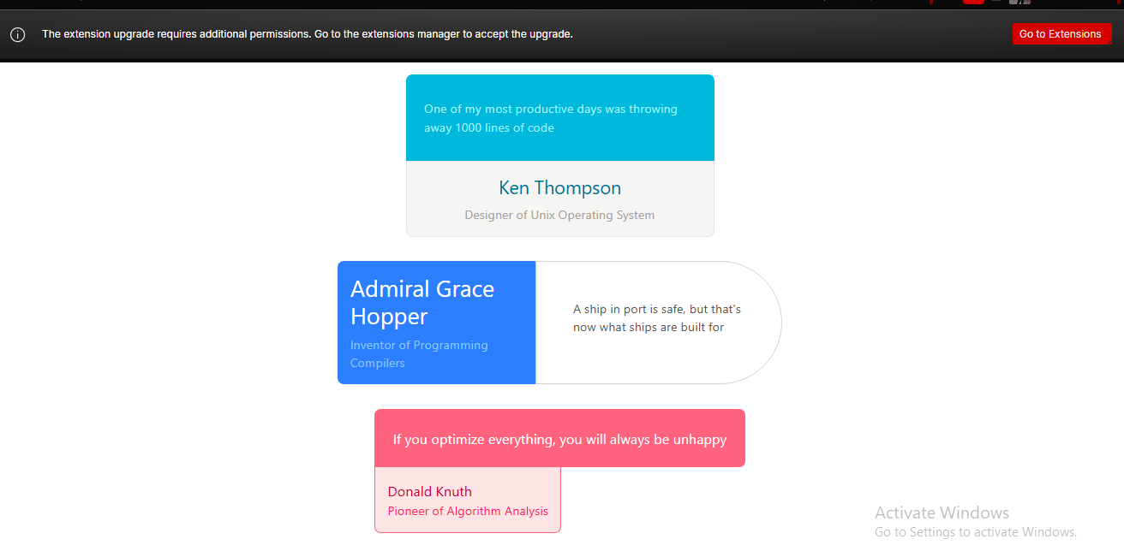
- PROJECT 1
App.jsx:
import Footer from "./Footer";
import Header from "./Header";
import Search from "./Search";

function App() {
return (
<>
<div className="h-screen flex flex-col">
<Header />
<Search />
<Footer />
</div>
</>
);
}

export default App;

Header.jsx:
import { faUser } from "@fortawesome/free-solid-svg-icons";
import { FontAwesomeIcon } from "@fortawesome/react-fontawesome";

const Header = () => {
return (
<div className="bg-orange-200 flex justify-between px-4 py-2 text-orange-500">
<div className="flex items-center">
<div className="mx-4">About</div>
<div className="mx-4">Store</div>
</div>
<div className="flex items-center">
<div className="mx-4">Settings</div>
<div className="mx-4">
<FontAwesomeIcon icon={faUser} className="text-3xl text-violet-600"/>
</div>
</div>
</div>
);
}

export default Header

Search.jsx:
import { faMagnifyingGlass } from "@fortawesome/free-solid-svg-icons";
import { FontAwesomeIcon } from "@fortawesome/react-fontawesome";

const Search = () => {
return (
<div className="flex flex-1 flex-col justify-center items-center bg-orange-100 ">
<div className="text-6xl text-orange-500 mb-4">Foogle</div>
<div className="flex bg-orange-200 border border-orange-300 p-2 rounded-full w-80">
<FontAwesomeIcon icon={faMagnifyingGlass} className="text-xl text-orange-400 ml-1"/>
<input className="flex-1 bg-orange-200 mx-1"/>
</div>
<div className="mt-4">
<button className="m-1 rounded-md bg-violet-200 text-violet-400 px-4 py-2">Foogle Search</button>
<button className="m-1 rounded-md bg-violet-200 text-violet-400 px-4 py-2">Image Search</button>
</div>
</div>
);
};

export default Search;

Footer.jsx:
import { faHeart } from "@fortawesome/free-solid-svg-icons";
import { FontAwesomeIcon } from "@fortawesome/react-fontawesome";

const Footer = () => {
return (
<div className="flex justify-between bg-violet-100 text-violet-400 p-2">
<div>This site is not real</div>
<div>
made with <FontAwesomeIcon icon={faHeart} className="text-red-600" /> and {" "}
<a href="https://tailwindcss.com" target="_blank" className="text-violet-500 underline">tailwindcss</a>
</div>
<div>by Adeyinka</div>
</div>
);
};

export default Footer;

Result:
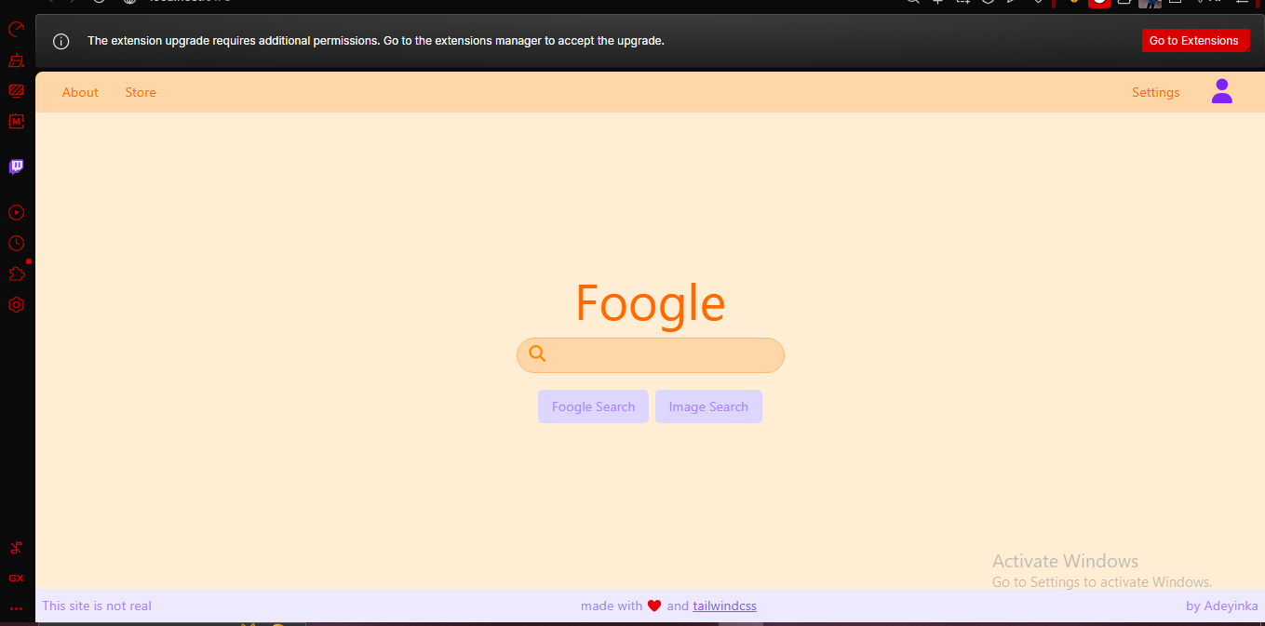
- EVENT HANDLING AND STATE
import { useState } from "react";

function App() {
const [message, setMessage] = useState("hello world!!!")
return (
<>
<div className="flex flex-col items-center justify-center h-screen">
<div className="text-3xl text-stone-400">{message}</div>
<div className="mt-4">
<button className="m-4 px-4 py-2 bg-green-400 rounded-md" onClick={() => setMessage("welcome")}>one</button>
<button className="m-4 px-4 py-2 bg-red-400 rounded-md" onClick={() => setMessage("yay!!")}>two</button>
<button className="m-4 px-4 py-2 bg-violet-400 rounded-md" onClick={() => setMessage("bye!!")}>
three
</button>
</div>
</div>
</>
);
}

export default App;

Result:
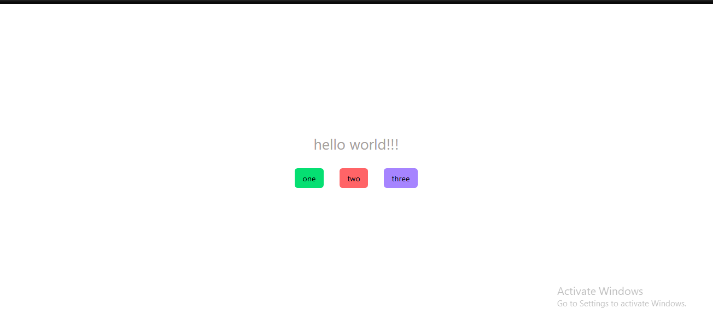
- CONDITIONAL RENDERING
App.jsx:
import Widget1 from "./Widget1";
import Widget2 from "./Widget2";
import Widget3 from "./Widget3";

function App() {

return (
<>
<div className="flex flex-col items-center">
<Widget1 />
<Widget2 />
<Widget3 />
</div>
</>
);
}

export default App;

Widget1.jsx:
import { faFaceLaugh } from "@fortawesome/free-solid-svg-icons";
import { FontAwesomeIcon } from "@fortawesome/react-fontawesome";
import { useState } from "react";

const Widget1 = () => {
const [showIcon, setShowIcon] = useState(false);
return (
<div className="bg-green-100 border border-green-300 p-4 rounded-lg m-4 flex flex-col items-center">
{showIcon ? (
<FontAwesomeIcon
icon={faFaceLaugh}
className="text-teal-500 text-3xl mb-4"
/>
) : null}

<button
className="px-4 py-2 text-white bg-teal-500 rounded-full"
onClick={() => setShowIcon(!showIcon)}
>
click me
</button>
</div>
);
};

export default Widget1;

Widget2.jsx:
import { useState } from "react";

const Widget2 = () => {
const [toggleColour, setToggleColour] = useState(false);

return (
<div className="bg-sky-100 border border-sky-300 p-4 rounded-lg m-4 flex flex-col items-center">
<button
className={`px-4 py-2 text-white rounded-full ${toggleColour ? "bg-orange-500" : "bg-blue-500"}`}
onClick={() => setToggleColour(!toggleColour)}
>
click me
</button>
</div>
);
};

export default Widget2;

Widget3.jsx:
import { faPoop } from "@fortawesome/free-solid-svg-icons";
import { FontAwesomeIcon } from "@fortawesome/react-fontawesome";
import { useState } from "react";

const Widget3 = () => {
const [showIcon, setShowIcon] = useState(false);
return (
<div className="bg-purple-100 border border-purple-300 p-4 rounded-lg m-4 flex flex-col items-center">
{showIcon &&
<FontAwesomeIcon
icon={faPoop}
className="text-purple-400 text-3xl mb-4"
/>
}

<button
className="px-4 py-2 text-white bg-purple-400 rounded-full"
onClick={() => setShowIcon(!showIcon)}
>
click me
</button>
</div>
);
};

export default Widget3;

Result:
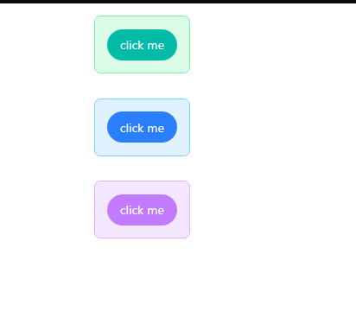
- PROJECT 2 (COUNTER)
import { useState } from "react";

function App() {
const [count, setCount] = useState(0);
return (
<>
<div className="h-screen text-4xl flex border border-black justify-center items-center">
<button
className="w-8 text-white bg-red-400 m-4 rounded-lg"
onClick={() => setCount(count - 1)}
>
-
</button>
<div className="m-4 text-neutral-400 text-center w-20">{count}</div>
<button
className="w-8 text-white bg-green-400 m-4 rounded-lg"
onClick={() => setCount(count + 1)}
>
+
</button>
</div>
</>
);
}

export default App;

Result:
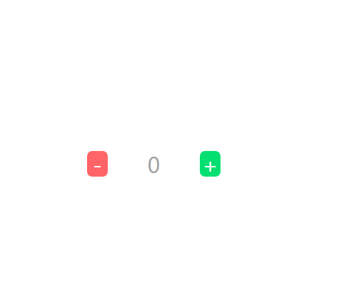

- PROJECT 3 (LIGHT SWITCH)
import { useState } from "react";

function App() {
const [isOn, setIsOn] = useState(false);
return (
<>
<div
className={`flex justify-center items-center h-screen ${isOn ? "bg-yellow-100" : "bg-slate-600"}`}
>
<button onClick={() => setIsOn(!isOn)}>
<div
className={`h-8 w-6 ${isOn ? "bg-slate-300" : "bg-slate-200"}`}
></div>
<div
className={`h-8 w-6 ${isOn ? "bg-slate-200" : "bg-slate-300"}`}
></div>
</button>
</div>
</>
);
}

export default App;

Result:



- PROJECT 4 (CAROUSEL)
import { FontAwesomeIcon } from "@fortawesome/react-fontawesome";
import fortnite from "./img/fortnite.jpeg";
import gow from "./img/god of war.jpeg";
import gta5 from "./img/gta5.jpeg";
import mk from "./img/mortal kombat.jpeg";
import tr from "./img/tomb raider.jpeg";
import { faChevronLeft, faChevronRight } from "@fortawesome/free-solid-svg-icons";
import { useState } from "react";

const IMAGES = [fortnite, gow, gta5, mk, tr];

function App() {
const [imageIdx, setImageIdx] = useState(0);

return (
<>
<div className="flex flex-col">
<div className="text-center text-cyan-400 text-2xl">Image {imageIdx + 1}</div>
<div className="flex justify-center items-center">
<button
className="bg-orange-400 rounded-full w-8 h-8 text-orange-100"
onClick={() => {
if (imageIdx > 0) {
setImageIdx(imageIdx - 1);
}
}}
>
<FontAwesomeIcon icon={faChevronLeft} />
</button>
<img
src={IMAGES[imageIdx]}
className="m-8 rounded-lg w-80 h-80 object-cover"
/>
<button
className="bg-orange-400 rounded-full w-8 h-8 text-orange-100"
onClick={() => {
if (imageIdx < IMAGES.length - 1) {
setImageIdx(imageIdx + 1);
}

}}
>
<FontAwesomeIcon icon={faChevronRight} />
</button>
</div>
</div>
</>
);
}

export default App;

- PROJECT 5 (CAROUSEL 2)
App.jsx:
import PeopleCard from "./PeopleCard";
import NavButton from "./NavButton";
import {
faCircleChevronLeft,
faCircleChevronRight,
} from "@fortawesome/free-solid-svg-icons";
import PEOPLE from "./people";
import { useState } from "react";

function App() {
const [peopleIdx, setPeopleIdx] = useState(0);
return (
<>
<div className="flex justify-center items-center">
<NavButton
icon={faCircleChevronLeft}
show={peopleIdx > 0}
onClick={() => {
setPeopleIdx(peopleIdx - 1);
}}
/>
<PeopleCard people={PEOPLE[peopleIdx]} />
<NavButton
icon={faCircleChevronRight}
show={peopleIdx < PEOPLE.length - 1}
onClick={() => {
setPeopleIdx(peopleIdx + 1);
}}
/>
</div>
</>
);
}

export default App;

PeopleCard.jsx:
const PeopleCard = ({ people }) => {
return (
<div className="border border-neutral-500 m-6 rounded-lg">
<img
src={people.imageUrl}
className="w-80 h-64 object-cover rounded-t-lg"
/>
<div className="p-4">
<div className="flex text-neutral-500">
<div className="mr-2 font-bold w-24">Name</div>
<div>{people.name}</div>
</div>
<div className="flex text-neutral-500">
<div className="mr-2 font-bold w-24">Age</div>
<div>{people.age}</div>
</div>
<div className="flex text-neutral-500">
<div className="mr-2 font-bold w-24">Sex</div>
<div>{people.sex}</div>
</div>
<div className="flex text-neutral-500">
<div className="mr-2 font-bold w-24">Location</div>
<div>{people.location}</div>
</div>
</div>
</div>
);
};

export default PeopleCard;

people.js:
import p1 from "./img/face1.jpg";
import p2 from "./img/face2.jpg";
import p3 from "./img/face5.jpg";
import p4 from "./img/face10.jpg";
import p5 from "./img/face7.jpg";

const PEOPLE = [
{
name: "Diana",
age: 20,
sex: "Female",
location: "UK",
imageUrl: p1,
},
{
name: "John",
age: 28,
sex: "Male",
location: "Argentina",
imageUrl: p2,
},
{
name: "Micheal",
age: 25,
sex: "Male",
location: "Spain",
imageUrl: p3,
},
{
name: "Lucy",
age: 30,
sex: "Female",
location: "Brazil",
imageUrl: p4,
},
{
name: "Gabriele",
age: 36,
sex: "Male",
location: "Italy",
imageUrl: p5,
},
];

export default PEOPLE;

NavButton.jsx:
import { FontAwesomeIcon } from "@fortawesome/react-fontawesome";

const NavButton = ({ icon, onClick, show }) => {
if (show === false) {
return null;
}
return (
<button
className="bg-green-400 text-green-200 rounded-md"
onClick={onClick}
>
<FontAwesomeIcon icon={icon} className="m-2 text-3xl" />
</button>
);
};

export default NavButton;

